

**ANL252**

**Python for Data Analytics**

**Tutor-Marked Assignment July 2022 Presentation**

**Name：Lee Zhu  
PI Number: Q2110768  
Date of Submission: 14 Aug 2022**

(a) Putting myself into the shoe of a HR practitioner, the data points i will focus on is:   
  
Citizenship  
The reason for looking at this specific data point is to manage the ratio of Citizens to PRs to Non-residents as there is a quota to maintain. A company may need access to foreign talents and at the current moment, they can have 7 S-pass holders for every local employee.   
  
In situations of rapid expansion, this data could be useful for the management to quickly make hiring decisions.  
  
Out of the 250 employees, the representation of the demographics is as follows.   
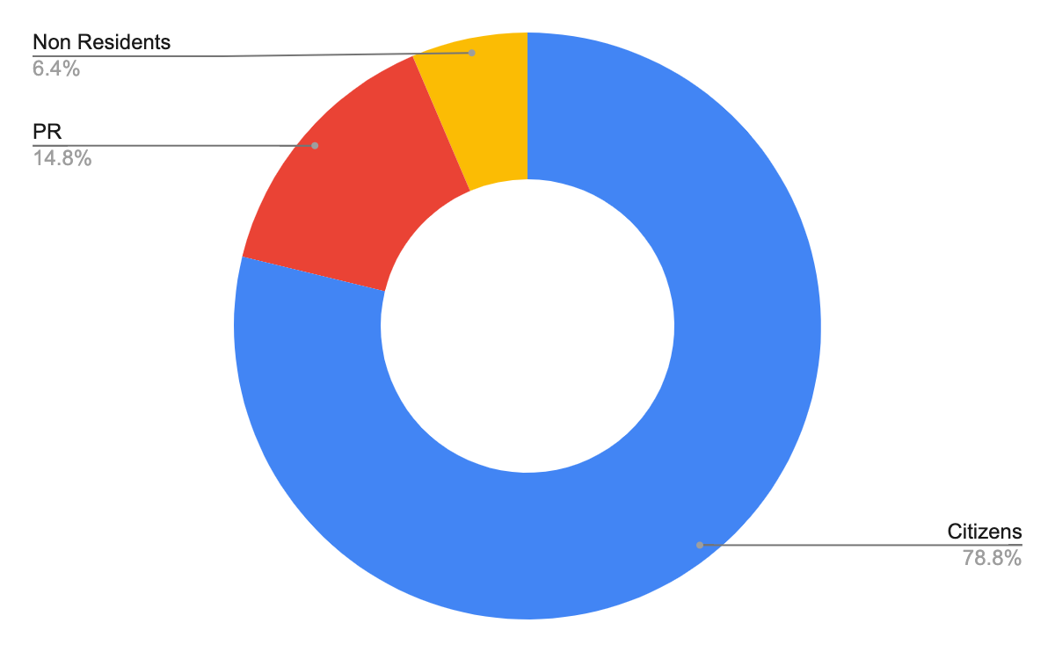

| Citizens | 197 |
| --- | --- |
| PR | 37 |
| Non Residents | 16 |

The second data point I will look into will be the survey results. As a HR, the main job is to make sure that the employees are well settled in, and ensure the correlation of satisfaction and efficiency.  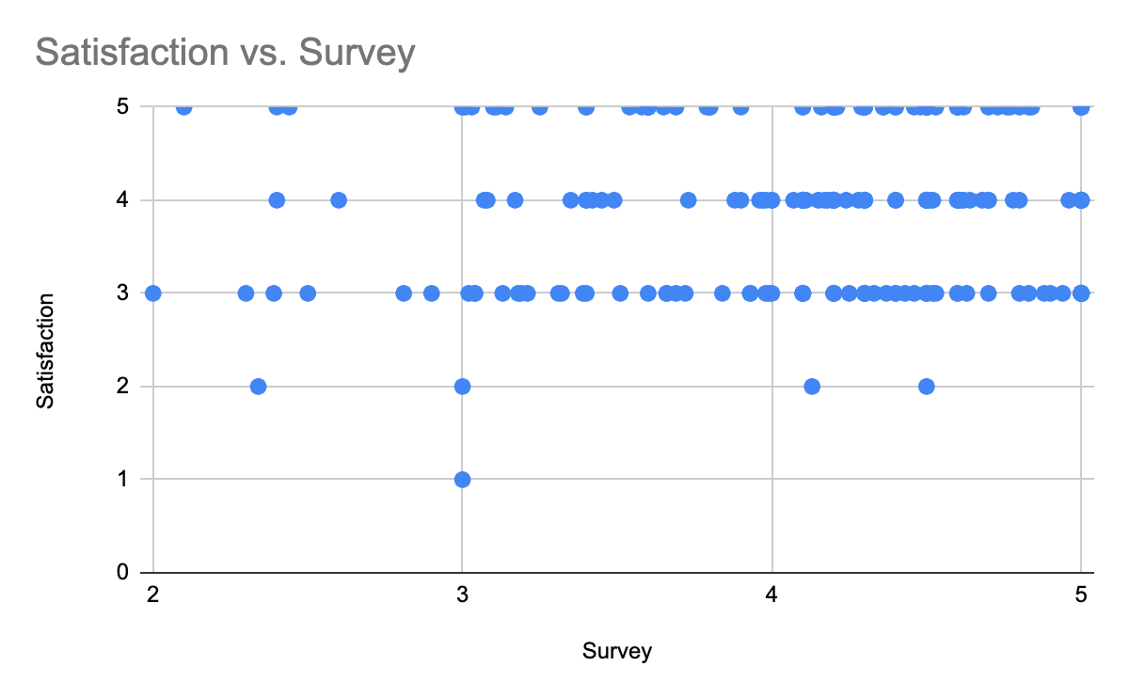A scatter plot of Satisfaction vs Survey could also help understand the sentiment in the company, as an indicator of how well the employees are adapting.